**Invention Disclosure Form**

**Detailed Invention Description**

This is a device to be used for minimally invasive endoscopic ear surgery. The invention builds upon a previously disclosed technology (the wrist mechanism), for which a provisional patent has already been filed by SickKids. This disclosure will focus on the handle that can actuate the wrist mechanism to bend the tip of the instrument.

*Base Design of Steerable Endoscopic Ear Surgery Instrument:*

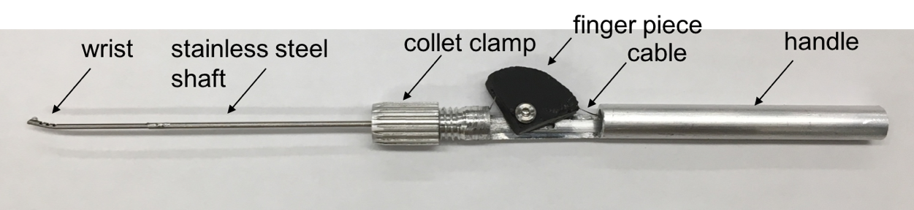

The wrist consists of CCM notches laser cut into a nitinol tube, connected to a stainless steel shaft that is clamped onto the handle that consists of a finger piece that controls the cable displacement of the cable attached to the nitinol wrist. Moving the finger piece back causes cable displacement and thus wrist actuation. The nitinol notched tube was laser cut in the CCM pattern by Pulse Systems, USA. The nitinol wrist was soldered to a stainless steel shaft that is clamped in a collet, using a collet clamp, at the distal end (tip end) of the handle. The handle was machined so the collet clamp could be threaded onto the distal end with enough room for the finger piece to rotate. The cable, soldered to the tip of the wrist, runs along the tube and is secured with a set screw inside the finger piece.

The handle is designed to be held like a pen so that it is comfortable, can be used alongside the endoscope during surgery and can perform fine, miniature movements at the tip.

*Adaptation to enable suction:*

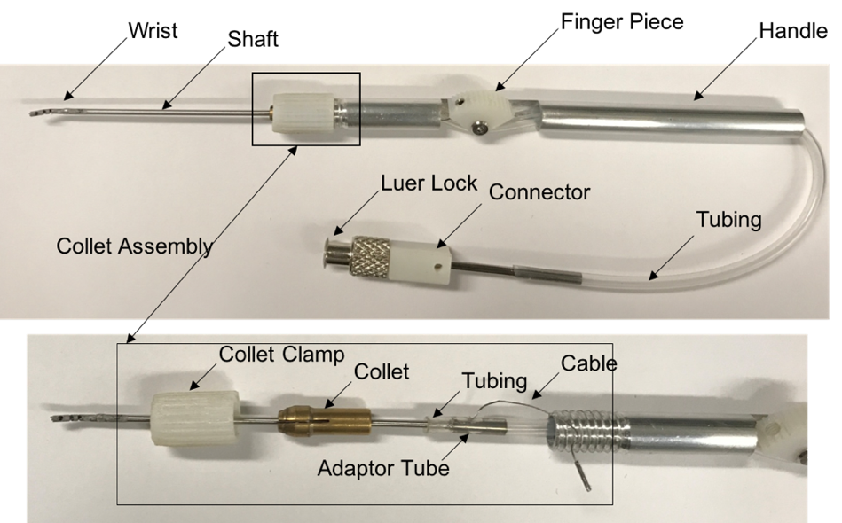

This instrument incorporates the wrist, and is therefore steerable, with the added functionality of suction. Plastic tubing is attached to the shaft and runs along the handle of the instrument and terminates at a connector which is connected to a luer lock. The luer lock allows the suction instrument to be connected to the suction port in the operating room. The zoomed in section shows that the cable exits the tubing and is accessible to be secured in the finger piece. The suction instrument is able to suction liquid.

*Adaptation to orient a laser fibre:*

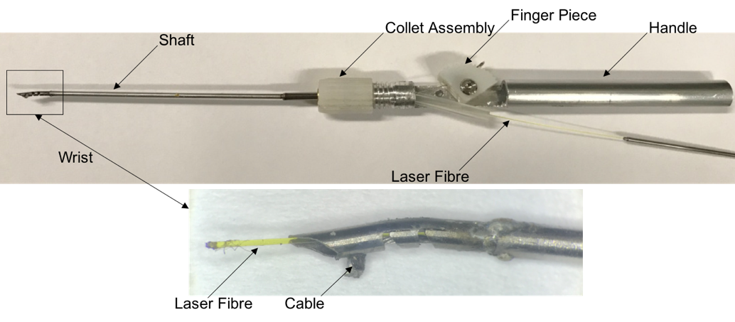

This instrument is manufactured similar to the suction tool prototype but instead of the tubing running along the handle, it provides a channel for the laser fibre to be fed through to the tip.

Furthermore, the device will be able to incorporate both suction and laser fibre orientation to suction the plume smoke after ablating tissue.

In order to reach areas during the surgery, and to provide an appropriate curvature so as to not damage the laser fibre when it is bent, the curvature of the wrist was adapted.